Astronomy And Engineering

# How do we know what we know?

1. The efficiency of telescopes are its diameter….the larger the diameter, the more is the area to let the light come through and hence, more efficient the telescope.
2. Here you can see the history of optical telescopes over the last 60 or so years. At the top, is the Palomar 200-inch. It was the largest in the world for decades, until a renaissance in telescope building in the 1980s and 1990s. See the cluster of large 8 and 10 meter telescopes that were built around that time. At the bottom, you see the huge telescopes being imagined or planned. On the right, you see the corresponding growth in the size of space-based telescopes, and it's much more modest because it costs an awful lot more money to launch something into space.

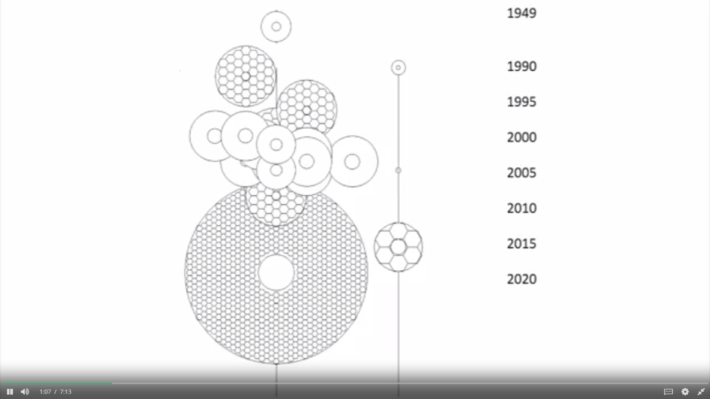

1. The two figures of merit of any telescope are both determined by its aperture or diameter. One, is fairly obvious, the collecting area which goes as the square of the diameter. The other figure of merit is angular resolution(*the smallest detail that can be observed in angle on the sky*). That's important not only for resolving features say on a planetary surface, but also for working in a crowded region like a galaxy or star cluster, seeing finer and finer detail and fainter and fainter objects. **Ground-based telescopes are limited in resolution by the blurring effects of the Earth's atmosphere**. Here's the relationship between angular resolution, the wavelength of radiation being used, and the diameter of the telescope.

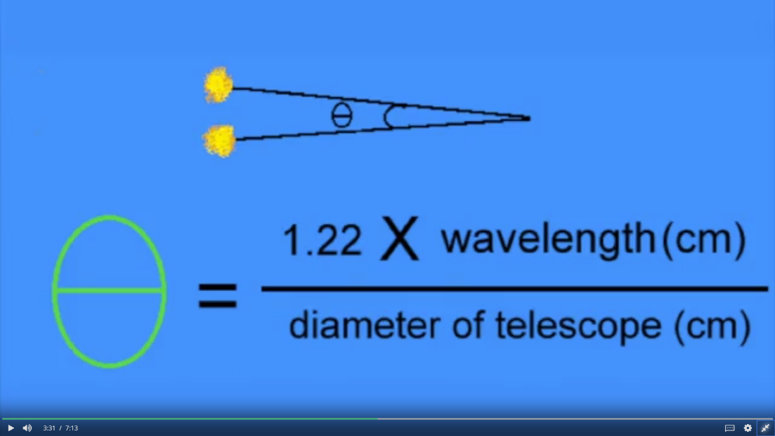

You can see that the **larger the telescope, the smallest the angle that can be resolved**(*also, it's proportional to the wavelength*).So shorter waves deliver higher angular resolution or more detail. Also, you can see**, it takes a large telescope to deliver a very small angular resolution**. But that blurring of light caused by the Earth's atmosphere, limits the utility of ground-based telescopes. Essentially, **any telescope more than about half a meter in diameter, is limited not by its optics, but by the blurring effects of the earth's atmosphere. This is a major limitation that astronomers have worked hard to overcome**.

1. There are two classic types of telescopes. One is a refractor. Familiar from the Galileo-scope and from Galileo's original device. This typically involves using two convex lenses contained in a tube to make an image. But it has serious problems as far as frontier research in astronomy go. The lenses have what is called chromatic aberration, where images of different waves of light are not formed in the same location. So you cannot bring the red and the blue light from a star or a galaxy, to a focus in the same place. Also, as you scale this telescope larger and larger, the length of the tube becomes extremely large, and the mass and weight of the telescope cause it to flex, which is a problem for image stability and quality. So in practice, no telescope larger than the Yerkes 39-inch, has ever been built and used for research.